PRODUCTION COMPANY | YOUR NAME | 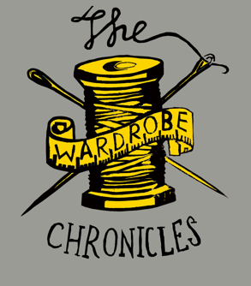
SHOW NAME | YOUR ROLE
THEATRE

MEASUREMENT SHEET – MALE

Name
Character Name

Chest
Waist
Hips
Inside Leg
Collar/Neck
Head
Shoulder
Arm Length
Waist – Floor
Boys Top Size (S/M/L)
Boys Bottom Size
Tattoos?
Piercings?
Allergies?
Height
Shoe Size
Hair Colour

The above information will be kept confidential.

PRODUCTION COMPANY | YOUR NAME
SHOW NAME | YOUR ROLE
THEATRE

MEASUREMENT SHEET – FEMALE

Name
Character Name

Chest
Waist
Hips
Inside Leg
Collar/Neck
Head
Waist – Floor
Girls Top Size
Girls Bottom Size
Bra size
Girl’s Dress Size
Tattoos?
Piercings?
Allergies?
Height
Shoe Size
Hair Colour

The above information will be kept confidential.

